Report of the Meteorological observations taken at Kenilworth, Kimberly , during the year 1899

Written to the secretary of the Meteorological commission for publication in the annual report of the Meteorological Commission.

J. R Sutton

B. A., Camb

* The Standard Barometer is by Negretti and Zambra , No.,1921, with a Kew Verification. In this fine instrument the cistern is fixed , while the scale which terminates in a fine zero point of ivory is caused to slide up and down the frame by means of a rack and pinion. The inside diameter is about 0.7 inch. Monthly and Annual Pressure Values are derived from the indications of the Standard Barometers are given for 3 different hours in Appendix 2.
* Column 2 of the Observations gives the Mean Pressure of the Day deduced from the hourly values measures on the Photo-barograms, beginning with midnight and ending with xxiii. The Barograph is a very good one of the usual pattern by Negretti and Zambra. The rays from a paraffin lamp are reflected by a concave spherical mirror through a condenser . passing over the space above the mercury in the Barometer tube, between the jaws of a long , vertical, narrow slit , whence a compound camera objective brings them to a focus upon a sheet of Bromide paper wrapped round a rotating drum. By means of a piece of mechanism attached to the clock a shutter cuts off the light for a few minutes every two hours , forming on the Barogram a series of equi-distant narrow white lines as Time- indicators . Temperature compensation is effected by the agency of a delicate system of zinc and glass rods , so arranged as to cause a slightly undulating base-line of reference ( varying with the temperature ) to be imprinted upon the Barograms.
* The charts are changed every second day at a few minutes past xxiii, and, generally speaking developed and measured once a week. The hourly ordinates are measured with a metal templet to the nearest .005 inch, and converted into true pressures in inches by comparison with regular control observations , taken 3 times daily , of the Standard Barometer. Ultimately therefore , the results may be regarded as approximately those of hourly observations with the Standard .
* In case of any temporary break in the Photographic record , the pressures are interpolated from the indications of a Recording Aneroid by Ross. This supplementary aid was required 3 times during the year i.e. for 4 hours in January, 3 hours in February, and 7 hours in September.
* The agreement at assigned hours between the results derived from the Barometer and Barograph separately is fairly satisfactory if we remember that the former is read to the nearest .001 inch. The Monthly Barometer Means for the 3 observatuons at viii, xiv and xx, are pretty much the same as the Monthly Means of the hourly Barograph values –a useful result- whence it follows that either should be approximately the same as the monthly means of Observations at ii. It is a curious fact that while the Mean Pressure of a month, calculated from a number of years of observations , may differ widely from any one of the months considered , yet no whole year, so far , has differed by more than .003 inch from 26.140 inches. This seems to indicate that a period of exceptionally high pressure will have been preceded or will be succeeded by a period of exceptionally low pressure. The curve of Diurnal Variations is practically identical in shape year after year.
* The general differences between the Standard Barometer and the Barograph are probably due to a number of causes. The chief seem to be :

1. The Barograph tube is smaller than that of the Standard, and the mercury column is more sluggish. The effect of this will be seen in Appendices 1 and 2 , where the differences at viii ( Standard *minus* Barograph) becomes greater in the winter as the morning maximum falls later in the day and the corresponding rate of rise at vii increases
2. The arrangement of the different parts in the erection of the Barograph apparently made the amplitude of the Photographic Pressure Curves , from the beginning , slightly too great for brass templet scale. The greatest and least pairs of nearly simultaneous readings during year have been:

July 27th at viii , Standard , 26.561 in., ; Barograph , 26.56 in.

Dec. 29th at xiv , Standard , 25.665 in. ;Barograph ,25.645 in.

1. The swelling and shrinking of the sensitised paper with changes of moisture.

I have not yet had the opportunity to determine by how much each of these demands separate numerical compensation, although like many other problems it has been noted for investigation. Still less have I attempted to correct the second in a re-arrangement of the parts by mere guess work, lest greater errors should result. The third source of error is doubles more considerable than would be dreamt of in English practice. A range of Atmospheric Humidity from 15% to 100% in less than 24 hours is by no means remarkable ; and as a result a Chart , which will fit closely and well , if put under the former , dry condition , will become much too loose should the latter set in. indeed the fact introduces error into all the charted records –that of Wind –Velocity in particular –save only in the time-scale of the Auxanometer Charts , where the recording pen writes time and magnitude at the same instant.

* All the Barometers are mounted in an outside room of raw brick; floor space 10x8 feet , height 9 feet ; walls nearly a foot thick . it contains no window but is well ventilated . the Diurnal Range of Temperature in this room is about 5˚
* The Minimum and Maximum shade Temperatures , the thermometers from which they are derived from are of the standard pattern by Negretti and Zambra, and Kew –Verified. They are :

Standard Maximum , No. 81.229, mounted 5 feet 2 inches above the ground.

Index –Error =-0˚.1 at 32˚. Fahr.

Standard Minimum , No. 81.580, mounted 4 feet 9 inches above ground .

No Index- Error.

Standard Minimum , No. 81.592, mounted 4 feet 4 inches above the ground.

No Index-Error.

They are mounted in a large , handsome , single-louvred wooden Screen of 8x8x8 feet , about 2 feet from the louvres , and arranged , consistently with firmness and security , as to be as nearly as possible floating in free air. A board behind and below them serves to cut off possible radiation from the ground. It says much for the excellence of these thermometers , as well as for their housing , that , although they are mounted one above the other in a space of 10 inches , it is only in very rare occasions that any difference e has been detected in their simultaneous indications and 0˚.05 would probably represent its greatest amount.

* Comparison observations are taken with Kew-verified Maximum and Minimum Thermometers in a Stevenson Screen ( not the latest pattern as adopted by the Royal Meteorological Society ) ;but the readings since 1897 get no further than the note-book.
* My experience has been that with the usual light winds , clear skies and intense radiation at this place , it is seldom that any two different spots inside the Stevenson Screen have the same temperature , and only during occasional strong winds do the Thermometers inside it read alike. To show how the large and small Screens compare , the Mean Monthly Values for 1987 are here annexed :-

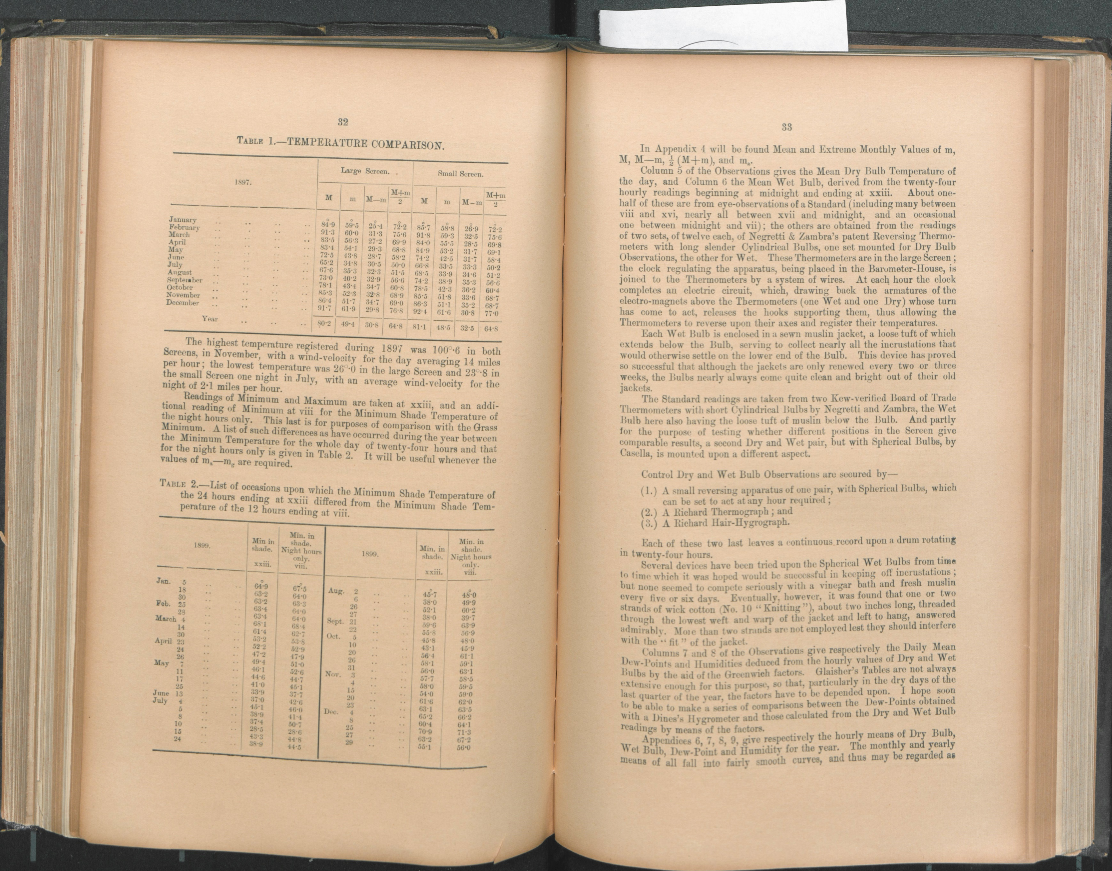

The highest temperature registered in 1897 was 100˚.6 in both Screens , in November , with a wind-velocity for the day averaging 14 miles per hour ; the lowest temperature was 26 ˚.0 un the large Screen and 23˚.8 in the small Screen one night in July , with an average wind-velocity for the night of 2.1 miles per hour.

Readings of Minimum and Maximum are taken at xxiii, and an additional reading of Minimum at viii for the Minimum Shade Temperature of the night hours only. This last is for purposes of comparison with the Grass Minimum. A list of such difference as have occurred during the year between the Minimum Temperature for the whole day of 24 hours and that for the night hours only is given in Table 2. It will be useful whenever the values of ma –mg are required.

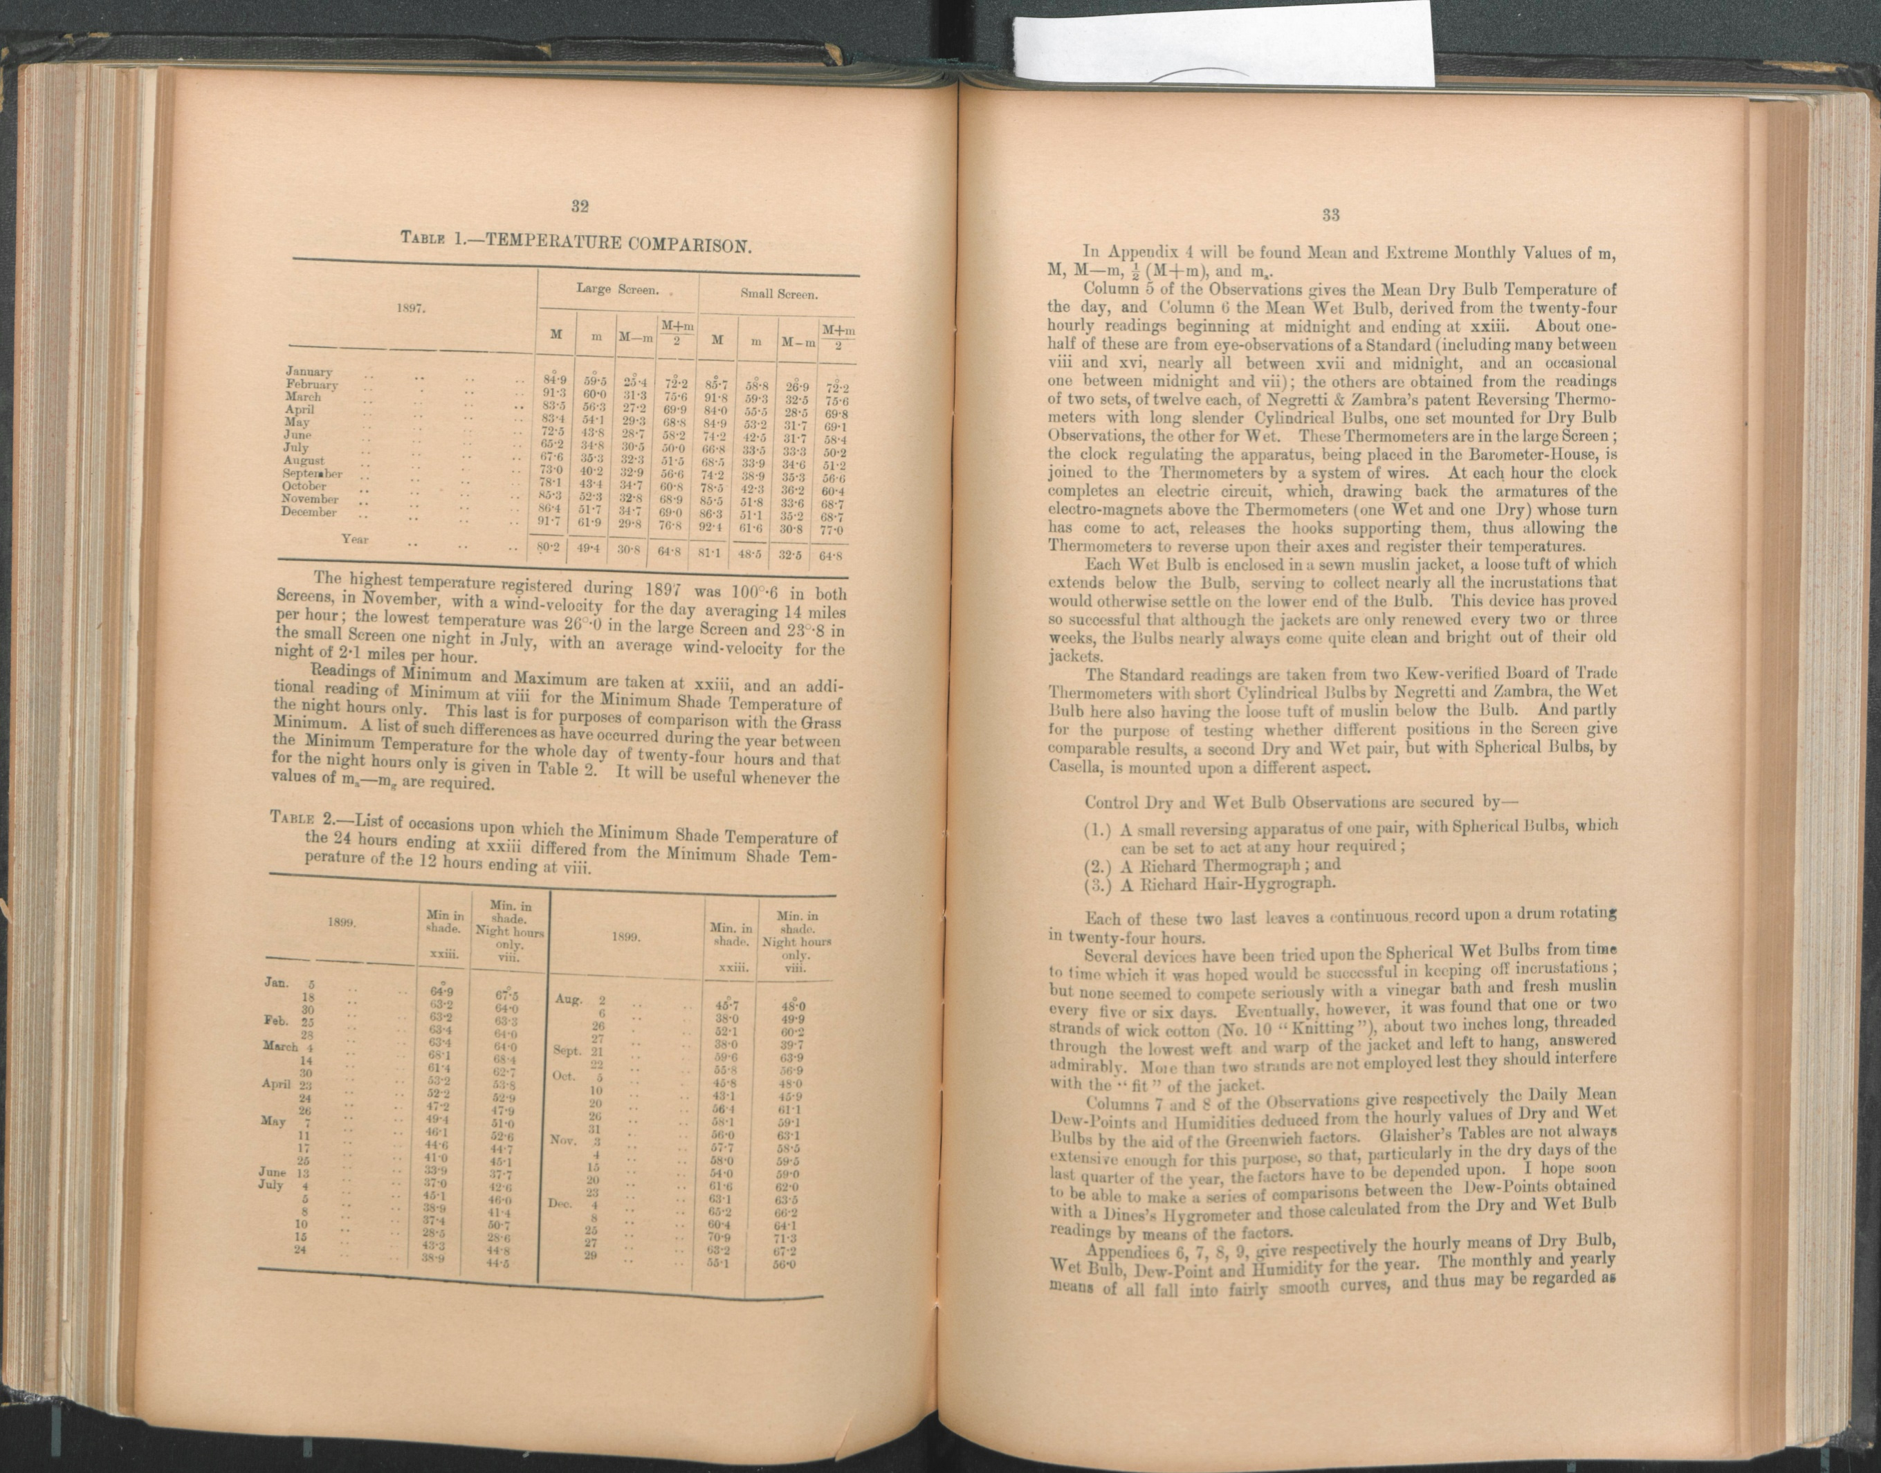

* Observations of Mean Dry Bulb Temperature of the day ,and the Mean Wet Bulb , derived from 24 hourly readings beginning at midnight and ending at xxiii. About one half of these are from eye-observations of a Standard ( including many between viii and xvi , nearly all between xvii and midnight , and an occasional one between midnight and vii); the others obtained from the readings of 2 sets, of 12 each, of Negretti an Zambra’s patent Reversing Thermometers with long slender Cylindrical Bulbs , one set mounted for Dry Bulb Observations, the other for Wet. These thermometers are in a large Screen ; the clock regulating the apparatus , being placed in the Barometer- House, is joined to the thermometers by a system of wires. At each hour the clock completed an electric circuit , which drawing back the armatures of the electro-magnets above the thermometers ( one Wet and one Dry ) whose turn has come to act, releases the hooks supporting them , this allowing the thermometers to reverse upon their axes and register their temperatures.
* Each bulb is enclosed in a sewn muslin jacket , a loose tuft of which extends below the Bulb, serving to collect nearly all the incrustations that would otherwise settle on the lower end of the Bulb. This device has proved so successful that although the jackets are only renewed every 2 or 3 weeks , the Bulbs nearly always come quite clean and bright out of their old jackets.
* The Standard readings are taken from two Kew-verified Board of Trade thermometers with short Cylindrical Bulbs by Negretti and Zambra , the Wet Bulb here also having the loose tuft of muslin below the Bulb. And partly for the purpose if testing whether different positions in the Screen give comparable results, a second Dry and Wet pair , but with Spherical Bulbs , by Casella , is mounted upon a different aspect.

Control Dry and Wet Bulb Observations are secured by-

1. A small reversing apparatus of one pair , with Spherical Bulbs , which can be set to act at any hour required
2. A Richard Thermograph ; and
3. A Richard Hair-Hydrograph

Each of these 2 last leaves a continuous record upon a drum rotating in 24 hours.

* Several devices have been tried upon the Spherical Wet bulb from time to time which it was hoped would be successful in keeping of incrustations ;but none seemed to compete seriously with a vinegar bath and fresh muslin every 5 or 6 days. Eventually , however , it was found that 1 or 2 strands of wick cotton( No.10 “Knitting”), about 2 inches long, threaded through the lowest weft and warp of the jacket and left to hang , answered admirably. More than 2 strands are not employed lest they should interfere with the ‘fit’ of the jacket.
* The observation for the Daily Mean Dew-Points deduced from the hourly values of Dry and Wet Bulbs by the aid of the Greenwich factors. Glaisher’s Tables are not always extensive enough for this purpose , so that , particularly in the dry days of the last quarter of the year , the factors have to be depended upon. I hope soon to be able to make a series of comparisons between Dew-Point obtained with a Dine’s Hygrometer and those calculated from the Dry and Wet Bulb readings by means of the factors.
* The monthly and yearly means of all ( Dry Bulb, Wet Bulb , Dew Point ) fall into fairly smooth curves , and thus may be regarded as approximately correct ,- very nearly as accurate , that is , as if all were the results of the eye observations.
* Affection for the Reversing Apparatus , preferably with the Cylindrical Bulbs, grows upon one. Abe and Symons have spoken highly of the performance of these instruments. It is doubtful if any other form of Registering or Recording Thermometer can give hourly valued with anything like the same accuracy . a great virtue consists of the fact that the readings come direct from Mercurial Thermometers pure and simple , and of a size found the most convenient and trustworthy in observations with ordinary sensitive Meteorological Thermometers. It would be a mistake , nevertheless , to suppose that good results ,may be reached by their aid without trouble. On the contrary it is probable that the Reversing Apparatus with its 24 thermometers , necessary for hourly observations of Dry and Wet Bulbs , requires more attention than the Dry and Wet Photo- thermograph. There is , to begin with, the period of time required in the operation of changing the jackets , - some 2 hours every 2 or 3 weeks . then the necessity for keeping the battery ( of 3 cells ) in first- class working order not waiting for it to go wrong before putting it right: for if this gets weak the magnets will decline to reverse the Thermometers, , and the clock hands are liable to hang up in making the contacts. On account of the difficulty in manipulating the electrical connections Symons pronounced in favour of a purely mechanical upset direct from the clock. This was indeed the early though of the inventors, and one of the first published illustrations of a working apparatus depicted 8 thermometers reversed directly by the clock. Perhaps something may be said on both sides : on the whole it may be claimed that it is not every person who, having the Battery , would willingly exchange it for the Mechanism. Again, there is the necessity for studying separately the idiosyncrasies if the 24 Thermometers, instead of 2 only in a Photographic instrument. Every meteorologist who is not a mere trifler knows, of course , that to observe with a Thermometer ( or any other physical instrument ) is not simply to take recordings from the same, but also to study continuously its performances under varying conditions. Without this study misleading results may be confidently anticipated.
* Careful and numerous tests reveal 2 or 3 notable peculiarities in the reversers , as compared with the behaviour of ordinary thermometers. The most important concerns the displacement of the zero-point with age. Considering 24 similar Thermometer made apparently from glass of uniform quality , of about the same age , and the subject from the beginning to identical vicissitudes of temperature, it might be expected that the zero-point would shift , if at all from the Bulbs pretty much at the same rate for each. This is not so. One of the set of Thermometers requires at this date a subtractive correction of 0˚.4 besides that vouched for at Kew. Another which was proved at Kew to read 0˚.4 too high over a great part of the scale reads now 0˚3 higher still; this being the 7th Wet Bulb, registering at vii and xix, mentioned in last year’s report. 1 or 2 others have increased their readings by 0˚.2. Some have not changed at all. In 2 curiously enough, the readings have decreased. Apparently these diverse movements are not due altogether, or even principally, to the shrinking of the glass; they are quite as likely to be due to an actual change of shape in the necks of the Thermometers whereby the contraction at which the Mercurial Column breaks away shifts from its initial position. This is only a surmise, and will not perhaps receive unqualified assent; but it seems to be independently corroborated by the fact that two of the original lot had to be set aside because the braking of the Mercurial Column no longer occurred in either instance at a fixed point of the neck, but might occur anywhere between the original critical point and the trap.
* The prince of Monaco , who has used thermometers of this pattern for deep-sea temperature investigations , has mentioned the risk incurred that after the thermometer has been reversed the mercury left in the Bulb may force itself, by virtue of its weight , past the contraction into the tube. I have had a Thermometer which behaved thus pretty often, filling up the whole of the tube ; but not, it is pleasant to relate , at this Observatory during the year. All such faults , however , may be shorn of some inconvenience by the simple ( and essential ) expedient of having at least four additional; Thermometers , in reverse against emergencies , with every complete Dry and Wet Bulb apparatus.
* As made , and used for Meteorological purposes, the tube of a Reversing Thermometer is enclosed in an outer sheath of glass which is fastened at the neck of the tube by a brass ferrule ; an inside pad of wash-leather and some plaster of paris keeping it firmly in place. For a Dry Bulb nothing better could be desired. For a Wet Bulb the advantage is not so obvious , because, as in the example of old forms of Grass-Minimum Thermometers , particles of water from the wick will sometimes contrive to insinuate themselves past the wash-leather pad into the sheath and fog it. Sometime ago I called Messrs. Negretti’s attention to this little difficulty and asked them to make e a number of Thermometers in which the sheath should be sealed to the tube with a glass joint. Unfortunately the result was not a success from the makers point if view. It appears that the heat if the flame used for the sealing process is apt to alter the shape of the parts adjacent to the trap, upon which the efficiency of these Thermometers depends. The obvious course to pursue under the circumstances, therefore, was to have a good length of open neck between the ferrule and the bulb , for the attachment of the wick, in order that moisture form the latter should not spread to the sheath. The plan is satisfactory.
* Another disturbance arises out of the discovery that sometimes a Reversing Thermometer registers a rising better than a falling temperature. This, doubtless, might be to some extent expected , and is likely to be most noticeable in climates where the thermal changes are rapid. It is not a matter of much moment, however , involving at its maximum effect only 1 or 2 tenths of a degree in excess. Normally the 3rd, 4th and 5th thermometers ( both Wet and Dry ) of an hourly apparatus will have nothing but falling Temperatures to register , and therefore in general their homonymic means may have a double excess from the above cause as compared to the rest. Fortunately these ordinals in the Kenilworth apparatus behave well.
* Finally there is a small expansion or contraction, of the mercury column , after a Thermometer has been reversed , according as the temperature rises or falls afterwards it is not great : reaching perhaps 0˚.1 on the scale for each change of 8˚ or 10 ˚. The total effect of this is peculiarity, together with that in the previous paragraph , is to slightly flatten the curves of the Dry and Wet Bulb, and thus make the Thermometers appear more sluggish than they really are. No correction has been applied to the observations on this account.
* Thirteen hours in all have been lost, for various reasons , by the Reversing apparatus during the year ; in 11 of these both Dry and Wet failed simultaneously , and in the other 2 hours the Wet Bulbs were frozen up. These have been interpolated from the records of the Thermograph and Hygrograph. As in independent scientific tool the Richard Thermograph is quite useless for rapidly changing air-temperatures . while it is fairly accurate during the night9 say from xx to v ), and during the hours before and after noon ( say from x to vii) in settled weather , its excessive sluggishness makes it quite 6˚ or 7˚ in error for many hours about the time of sunrise and sunset, and more still in sudden Temperature changes , such for example as might arise from the passage of a Thunderstorm. Yet if used with the caution it has its uses for interpolation purposes , and especially because it is on the whole only likely to be required during the night hours. The Hair Hygrograph is a very sensitive instrument , and deserves to be more widely used.
* The column on the observation of the Minimum temperature over a very bas substitute turf. The Spirit Thermometer used for this purpose has a Spherical Bulb , and is mounted upon a stand provided by the makers, which raised it about the three inches from the ground. Comparison Observation are taken from a similar instrument resting in the grass; but these readings are not formally entered into the Register, although they are preserved in the note-book. The utility if a Grass Minimum in such a place this wants demonstration.
* The column on the observation of the Maximum Temperature in the Sun derived from the indications of a Kew-verified Black Bulb *in vacuo* , without a Test-gauge, mounted on a post five feet above ground.
* Earth Temperatures under bare sand are observed at 6 different depths ranging from one inch to 6 feet. Ordinary Thermometers are used for the depths of 1 inches and 2 inches , the centres of their bulbs being at that depth, their scales projecting above the ground suitably protected from hail and other missiles. The temperatures at deeper levels are obtained by means of slow-action thermometers hung by chains in iron pipes in accordance with the method introduced by the late Mr. G. J. Symons. There are 4 sets of readings daily , namely;

At viii and xiv =1 inch, 1 foot, 2 feet.

At xx the whole series.

At xxiii 1 inch, 2 inches.

* Appendix 14 gives the Monthly Totals of Rainfall in hourly values from the records of the auxanometer , and also the Hourly Frequency. As might be expected from a single years ‘results the hourly quantities are irregular, but Frequency curve shows something more than a suspicion off Barometric affinities. It will be seen presently that the quantities are much less since august. During the life of the old tank there were 3 reasons for this , as mentioned in the report for 1898:

-1st that in light showers the air is seldom at saturation point, and consequently Evaporation and Rainfall go on simultaneously

-2nd , that in heavy showers water may be splashed over the sides

-3rd , that the site of the station is not good, and is overcrowded; the

Anemometer Post , with its large top-hamper of Anemometer and sunshine recorders , is close to the tank , and on the side from which most of the rain comes. The first difficulty applies equally now , and must always do so where evaporation and rainfall are read from one instrument ; the others are to a certain extent minimized. At best the Hourly Rainfall numbers are to be accepted as only approximate ratios.

* The column on the observations of the rainfall gives the daily quantities of rainfall collected in an 8 inch gauge of the Meteorological Office pattern, whose rim is 3 feet above the surface of the ground.it read at viii and xx , the latter hour being here considered the end of a rainy-day of 24 hours. The quantity of .000 , appearing here and there signifies rain of too small a quantity to admit of measurement , *i.e* ., something less than.005 inch. In addition to the Kenilworth gauge , the De Beers’ Company has erected 5 inch Snowdon gauges at different advantageous points on its extensive lands. A summary of the returns appears in appendix 15. Up to the end of august returns were also kindly furnished by the General Manager of the Kimberly Water-works Company from gauges at 2 of his pumping-stations. Altogether , the area commanded by the gauges is some 400 square miles. Unfortunately the Premier Mine and the De Beers’ Mine are only outside stations to send complete returns for the year. Mr F. W. Matthews , however , kindly came to the rescue with monthly totals for Kimberly, in continuation of his unique series which began in 1877.
* The column on the observation of the Velocity of the Wind in miles per days. It is made up from records of a Kew-pattern Robinson Anemometer with its cups 42 feet above the ground. The recording part of this instrument was designed by Mr Henderson , formerly of the De Beers Company , and is so arranged that a pen rises from 0 to its highest point once for every 2 and a half miles of wind, writing its record upon a sheet of paper wrapped round a Richard drum. The Anemometer has had a fair exposure hitherto , but will have to be raised , or removed to a better position, eventually. Monthly summaries , giving the Hourly Rates , are given in appendix 16. The total mileage is 4,378 miles less than that of last year. Wind directions and pressures are recorded using an Osler Anemograph. Monthly wind components for direction only , and for direction and velocity are given below :

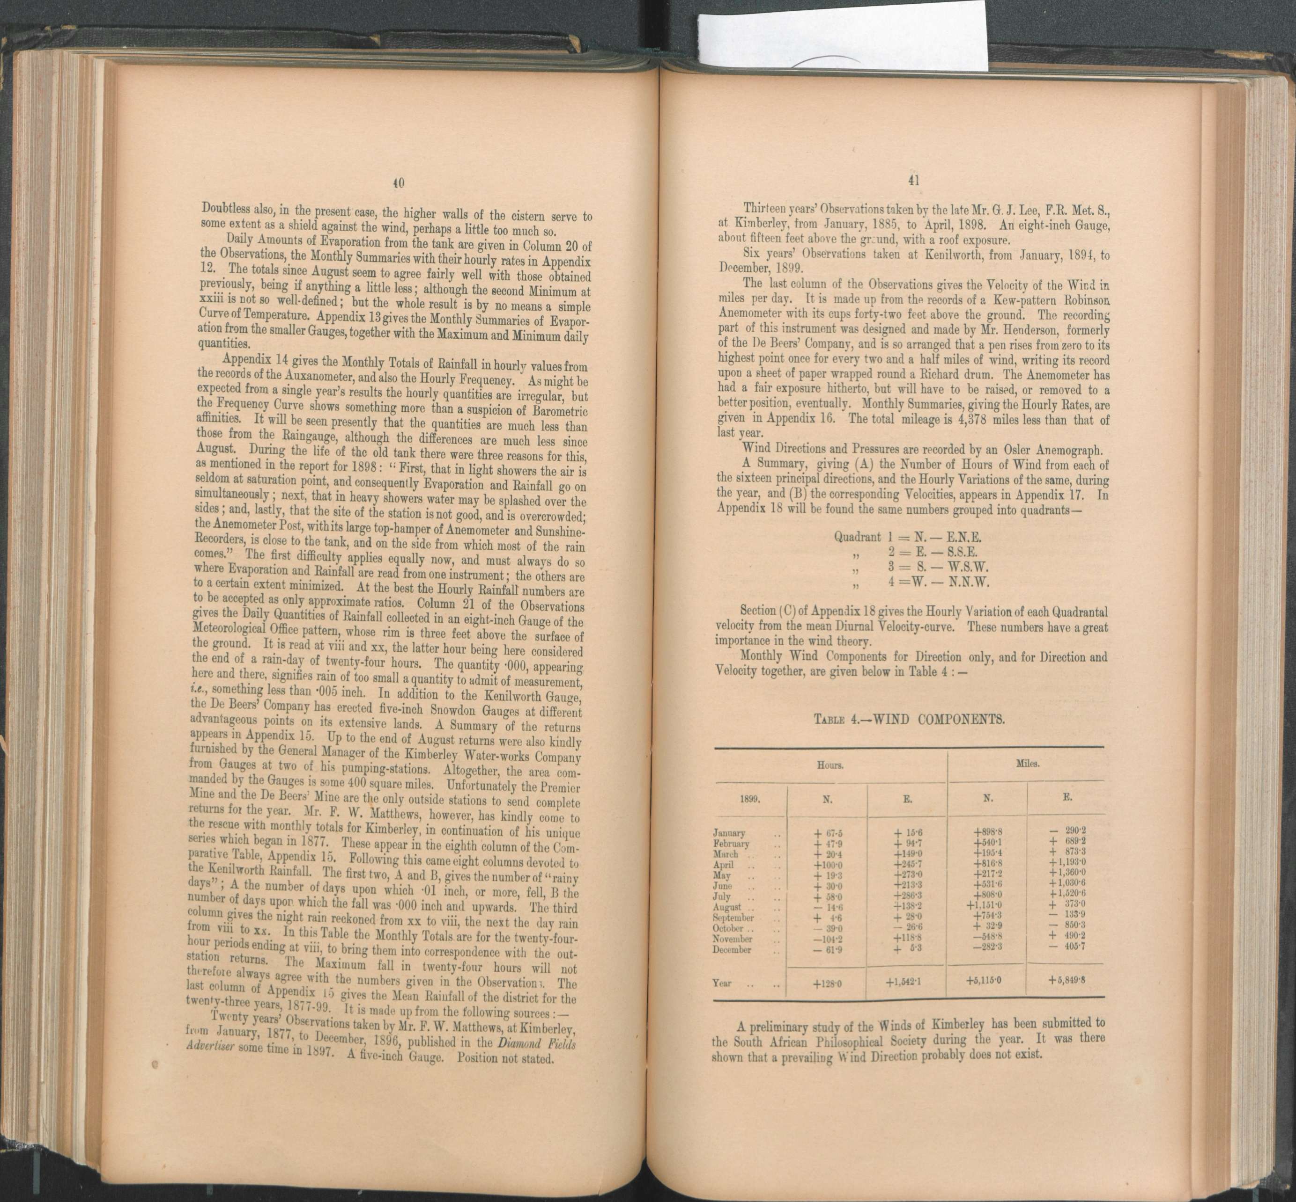

A preliminary study of the Winds of Kimberly has been submitted to the South African Philosophical Society during the year. It was there shown that a prevailing Wind Direction probably does not exist.

* The equipment for the observations of Earth Movement is not yet complete. It consists at present of 2Tromometers by the Cambridge Instrument Company, a Duplex Pendulum by the same makers, and a Milne Bracket Seismograph by Casella. 2 larger instruments were expected in October last, but have not yet come to hand.
* Not a single Telescopic Observation with the 4(1/2)inch Equatorial has been attempted during the year.
* Time has been kept by means of an Oliver’s Sundial. The approximate position of the Observatory is : Long. 24˚27’E ., Lat. 28˚ 42’S., Altitude about 3, 950 feet.
* The routine, and also the arrangement for preventing any break in the break records remain as last year.
* Weekly reports containing Daily Values of Barometer , Minimum and Maximum Shade and Radiation Temperatures , Earth Temperatures , and Rainfall, have been supplied to the *Diamond Fields Advertiser* as usual , and the same together with some additional information , to the Board of Health. The quantity of the miscellaneous information given to, and the number of Aneroids and Thermometers tested for different people and Institutions , have been about the same as in previous years.